**Materials List for ALL instruments:**

* Instrument
* Pencil
* Folder
* Rosin (any size and any color will work)
* A cloth to clean the excess rosin.

ACCESSORIES LIST, For violins and violas:

* ***\*\*\*Shoulder rest (helps with holding the instrument on the shoulders)***
  + There are different types of shoulder rest, the best option is to get a hard shoulder rest rather than a “sponge.” The best brands are Viva or Everest. *(Make sure to get the correct size for the violin or viola).*

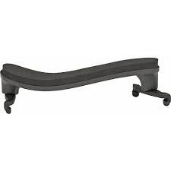*Here is an example of a good shoulder rest.*

ACCESSORIES LIST, For cello and bass:

* **\*\*\*Endpin Strap (will stop the cello or bass from slipping)**
  + Make sure to ask for a cello endpin strap OR a bass endpin strap. They are slightly different in lengths.

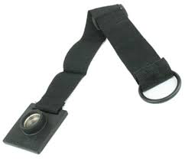Here is a picture of an endpin strap.

*\*\*\*These materials are important with helping the students play comfortably, and to help them get the most out of their learning.*